<https://docs.aws.amazon.com/AWSEC2/latest/UserGuide/ebs-describing-volumes.html>

## **View free disk space**

You can get additional information about your EBS volumes, such as how much disk space is available, from the Linux operating system on the instance. For example, use the following command:

[ec2-user ~]$ **df -hT /dev/xvda1**

Filesystem Type Size Used Avail Use% Mounted on

/dev/xvda1 xfs 8.0G 1.2G 6.9G 15% /

* **Access files through FileZilla:**

Path: /opt/bitnami/wordpress

* **To connect with AWS filezilla get** “Public IPv4 DNS” from AWS instance as Host and “bitnami” as username in case of bitnami wordpress and your password will be nothing or black.

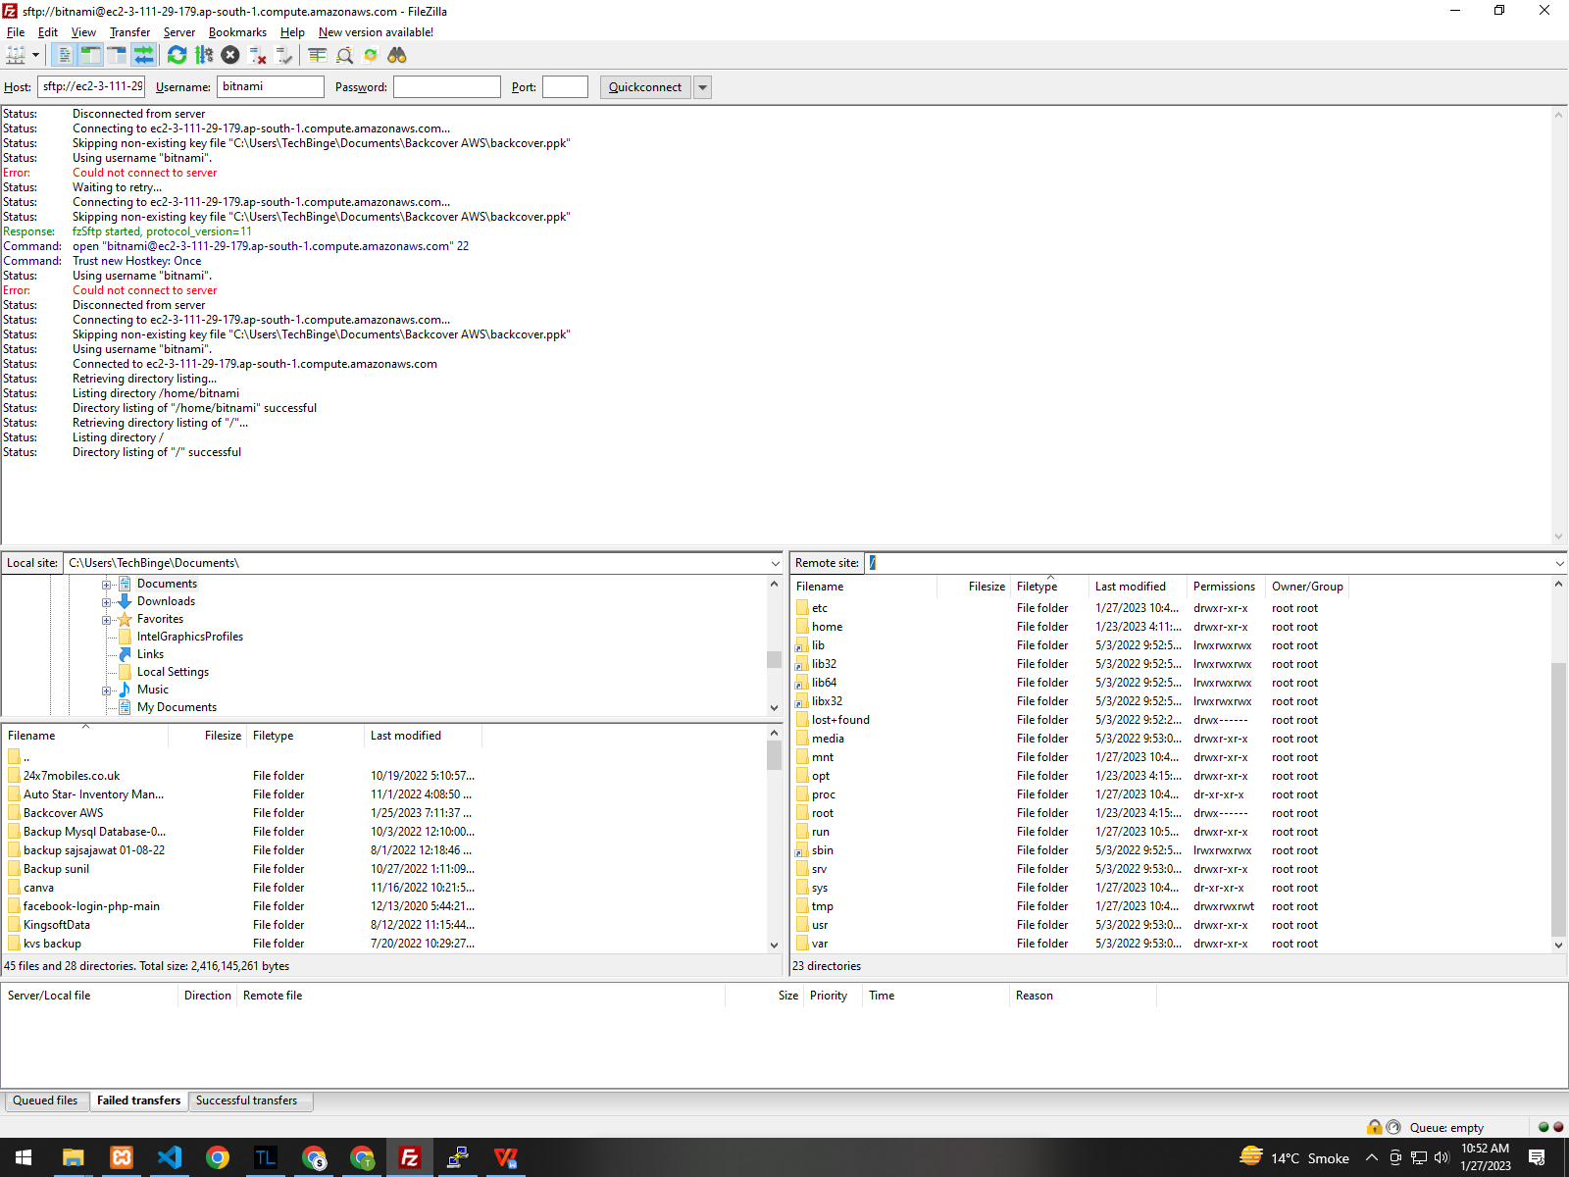

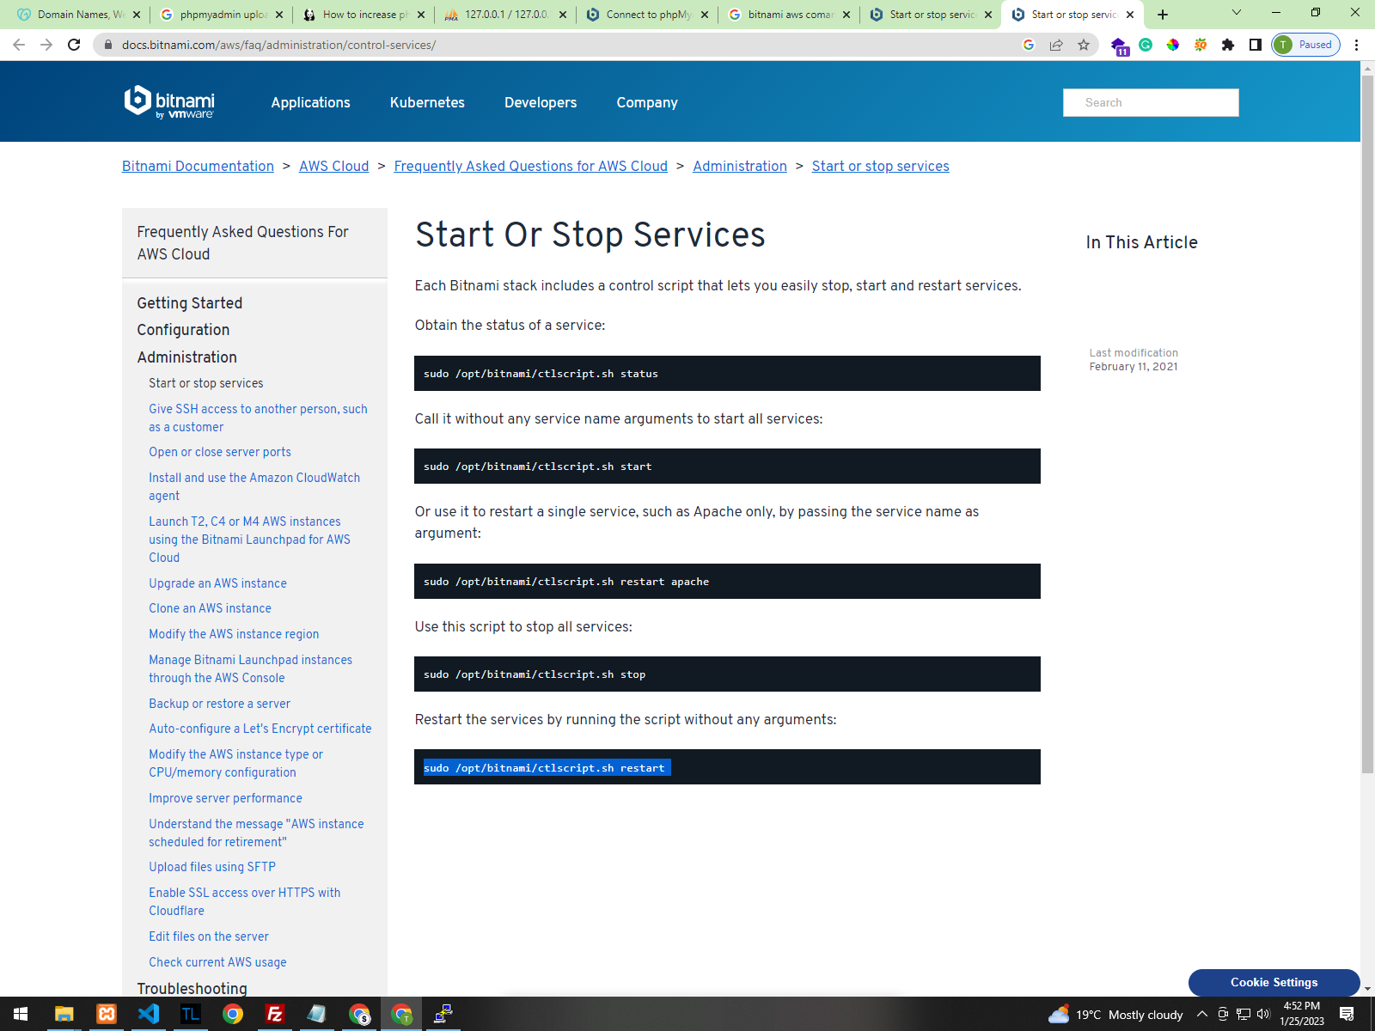

<https://docs.bitnami.com/aws/faq/administration/control-services/>

To Check current upload file size in phpmy admin follow below cmd:

grep -i "upload_max_filesize" /opt/bitnami/php/etc/php.ini

grep -i "post_max_size" /opt/bitnami/php/etc/php.ini

* To restart server use below cmd:

sudo /opt/bitnami/ctlscript.sh restart

sudo unzip -o "backcover (1).zip"

ls -l

sudo mv "backcover (1).zip" ..

* **To rename any file:**

Sudo mv wordpress wordpress-old

* To give write permission to directories and files

sudo chmod -R 777 /opt/bitnami/wordpress-test

:- Must give full path

* To move a file to any other directory

sudo mv backcover.zip ..

* To Unzip a zip file

Sudo unzip backcover.zip

* TO remove or delete a non empty directory

rm -rf trip-pictures

:- rm trip-pictures

* Do not allow allow all Read, write and exe. Permission to to Main **“bitnami”** folder, **it will restrict phpmyadmin panel to run .**

**If done please follow the cmd to reset the permission:**

sudo chmod -R 777 /opt/bitnami/wordpress-test

* Public IPv4 DNS : is used in filezilla to connect with ftp.

Eg: ec2-15-207-106-78.ap-south-1.compute.amazonaws.com